Mark Shim
Jose Roca
Chris Savorelli
Chris De Ceglie

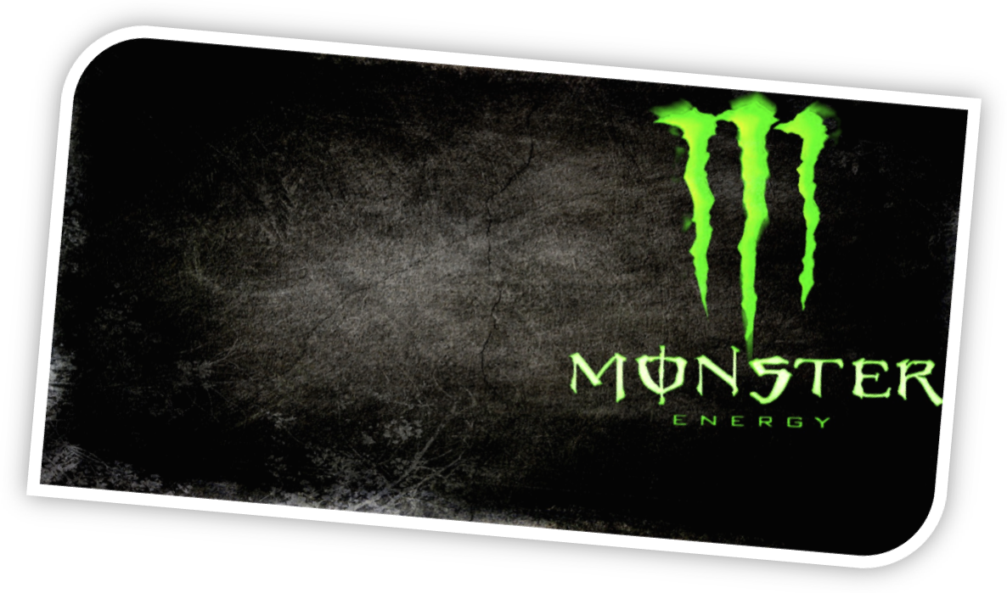

Executive Summary

Monster Energy drinks are regarded as some of the best tasting and highest value energy drinks in current production. Monster has been actively expanding into several new countries and we feel Japan is an opportunity waiting for Monster. Japan is a country with a very rich history and a history of taking well to new products. Japan is a country of great wealth and is on the same level as the United States in terms of national wealth. Japan has also historically taken well to American products and ways of life
To introduce Monster Energy to Japan, we would recommend keeping the brand image and messaging broadly the same, but with some minor cultural tweaks. Unlike the Unites States. Green does not have the same significance in Japan. We would recommend the primary color be changed to orange. This color represents vitality and energy in Japan, the exact qualities we would like the consumer to feel they are getting from the product. This color is already used in the Monster line-up and the particular shade used should work well in the Japanese market.
We would also recommend the slogan be changed. Although we would like the message be the same, we feel “Unleash the Beast” is to aggressive for the Japanese. We would recommend a slogan such as “Release you Inner-Dragon” to capture both the Japanese culture and transmit the message that Monster makes you more then you would be without it.
We would take advantage of our ongoing relationship with Coca-Cola and use their extensive distribution network in Japan to distribute the product.
We have no doubt that Monster will become successful in the Japanese energy drink market. The energy drink market is strongly established and continuously growing with the tireless Japanese.
Table of Contents

Executive Summary 2

Product Description 5

Country Description 6

Political Climate 9

Recommendations for marketing: 10

Market Segmentation: 12

Competitive Environment 13

Channel options 12

Communications Strategy 16

Pricing Strategy 17

Product Description

Monster Energy drink was launched and developed by Hansen Natural in 2002. Hansen is a publicly traded company on the NASDAQ based out of Corona, California. The main source and use of Monster is an energy supplement. The product is highly caffeinated and mixed with other ingredients to give the user a quick pick me up. The mixture of ingredients consists of; carbonated water, sucrose, glucose, panax ginseng root extract, guarana, taurine, and other ingredients designed to give the user an energy boost. Taurine is used as a lining for the stomach to help with the digestion process. Monster does put a disclaimer on their product to warn consumer about over consumption of the beverage. The majority of their ingredients does stay the same throughout their extensive product line which includes; Original, M-80, Rehab, Low-Carb, Mixxd, and the recently added Absolutely Zero. Monster has expanded drastically from their humble beginnings in 2002 with Monster Original.
The main target audience for Monster is males between the ages of 18-35. They focus most of their advertising towards college kids and extreme sports athletes. Monster does not use print or other traditional mediums for their advertising. They decided to allow their product to speak for itself. A majority of X-games athletes have endorsement contracts with the brand. Some of the athletes include Rob Dydrek, Mike Spinner, Dorien Walker, and Greg Lutzka. Monster also sponsors a motocross race team named Monster Energy/Pro Circuit Kawasaki. Furthermore, they host and sponsor the Vans Warped Tour, which is a punk rock concert held every year in the U.S.

Monster didn’t delay anytime going global with their products. They’re already established in; Mexico, Australia, New Zealand, France, and Germany. Monster uses Grupo Jumex to distribute their product in Mexico, and they use Pepsi’s distribution division to distribute their product in Germany. In Australia they have partnered with Schweppes to have their product distributed throughout Australia.
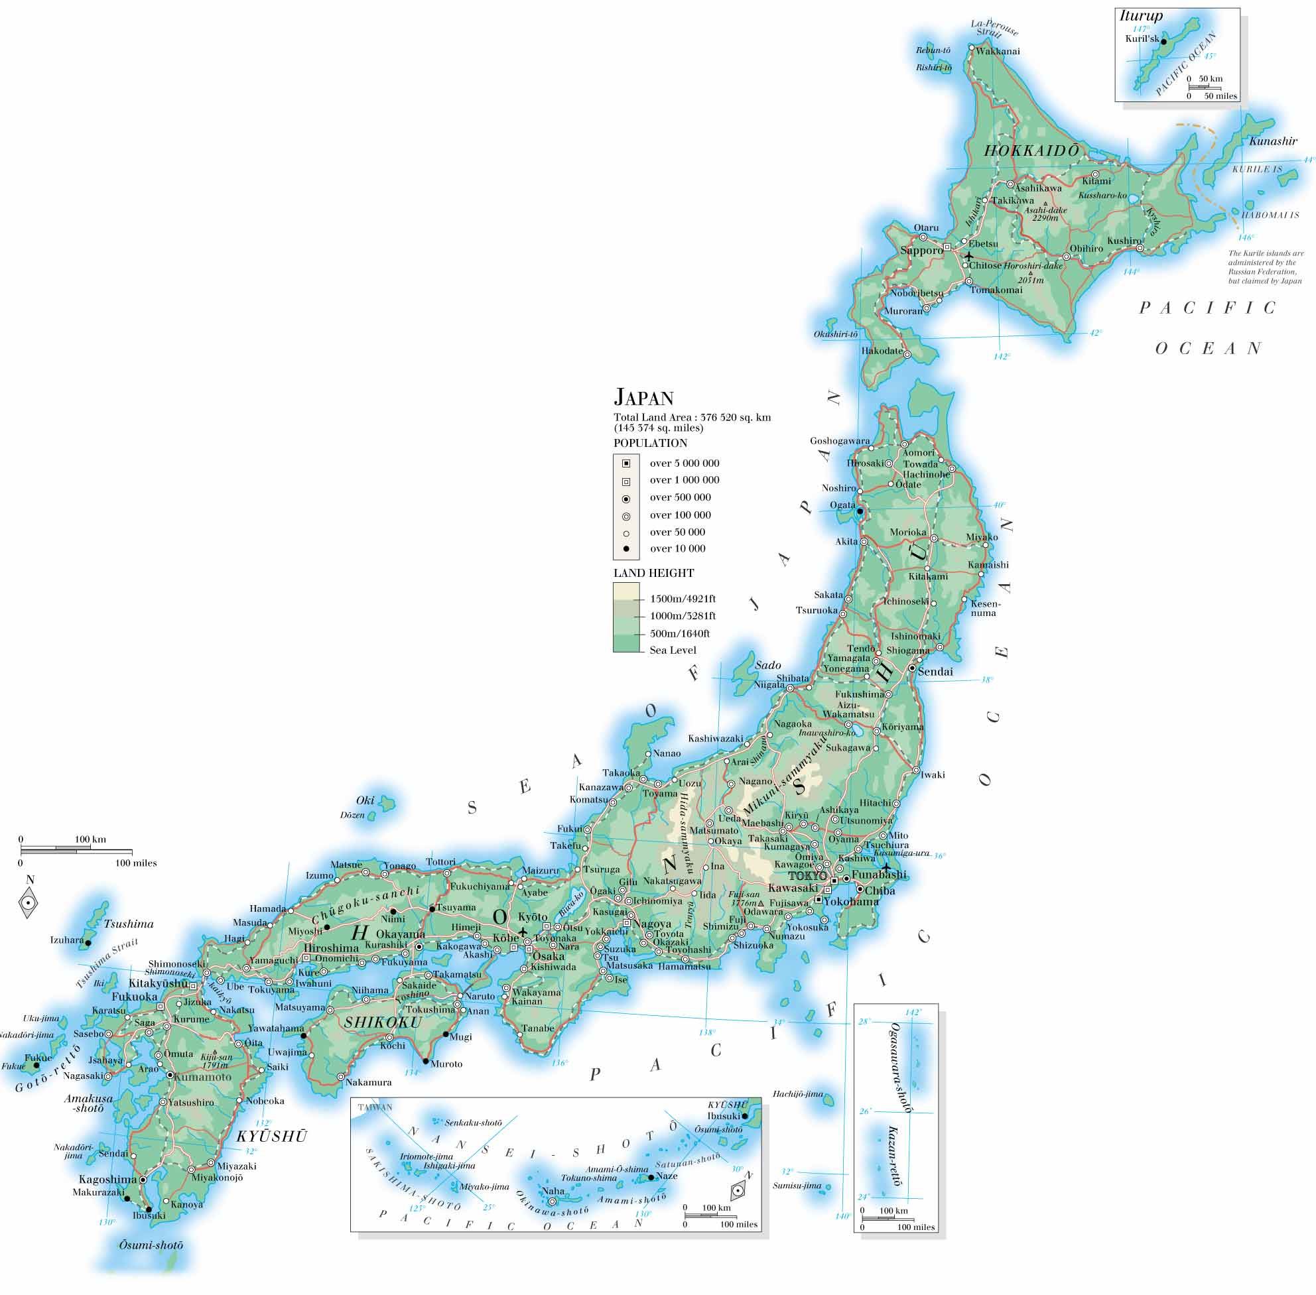
They way a company positions their product plays a very important role on how their product is going to be sold. Monster knew ahead of time that the energy drink market was dominated by Red Bull. They’ve approximately 48% of the market share. Red bull has priced their product at a price premium knowing consumers would pay it. This is likely caused by their strong brand equity. Monster chose a different approach when they positioned their product. To help differentiate Monster on the shelf, Monster’s containers are sized much larger than Red Bull. Monster smallest can is 16floz, which is almost double Red Bull smallest can which is 8.4floz. Red Bull prices their 8.4floz can around $2.35. However, Monster 16floz can is priced around $2.45. They want the consumers to recognize the value in only paying $.10 more they get double the amount of product. Monster wants the consumer to feel that they’re getting, “More bang for your buck.”

Country description

Japan is an island nation in eastern Asia. Japan is composed of four main islands and several smaller ones to make up a total land mass of about 378,000 square kilometers. That is approximately the size of California. Japan is a heavily mountainous country with a climate that varies from tropical in the southern regions to temperate in the more northern areas of the country.
Japan has a long history as does much of Asia, but the modern period started around 1600 with a military led, dynastic government. Japan had a period of 200 years of isolation and development of the native culture. It was not till 1854 that Japan opened up its ports to the United States that Japan started to integrate into a world economy. Japan quickly became a regional power and was able to fend off threats from its neighbors to include China. During WWII, Japan aligned itself with the Axis powers and occupied much of the Pacific. Japan attacked at Pearl Harbor in 1941 which triggered the US entry into WWII.
After the war, Japan quickly recovered and was again a powerful economic force. Japan experienced about thirty years of rapid growth until the 1990’s. Since then, Japan’s economy has remained strong but has for the most part stagnated as far as growth. With a GDP that has hovered around 4.2 to 4.3 trillion dollars over that past several years, Japan has a strong but mostly stagnant economy. That GDP is comprised mostly of the service industry (about 73%). The GDP per capita was about $34,000 US dollars, making Japan a high income county along with the other members of the triad (North America and Western Europe.
Japan also has a strong presence in the industrial products arena. Industrial products make up about 25% of Japan’s GDP and most of that industrial production is in high tech goods. Japan is generally regarded as one of the most technologically advanced counties in the production of motor vehicles (cars and motorcycles), electronic equipment (semiconductors, cameras), machine tools, metals, and other industrial products. The quality of Japanese industrial products is generally very high due to the pride taken in manufacturing, a common cultural attribute in Japan.
The remaining GDP (~1.5%) is made in agriculture. Most of this is done in the more traditional fashion in contrast to the large scale, mechanized farming in the United Stated.
The current Japanese population is about 126,500,000. Of those, 98.5% consider themselves of Japanese decent.. A .9% are of other East Asian decent. The remaining .6% is people of all other regions of the world. The primary language in Japan is Japanese and the national currency is the yen which is valued 76.65 yen to the dollar (at of 10/11/2011).
Japan has two primary religions. The two are Shintoism (84%) and Buddhism (71.5). Many Japanese follow both religions. And unlike most Western religions, Shintoism and Buddhism are more ways of living then the professions of faith that western religions tend to be.
The Japanese culture is drastically different that of the United States. In the United States and other western cultures, the emphasis I on the individual, “What can I do for myself?” In contrast, in most Asian cultures, the self tend to take a back seat to the needs of the group (family, community all the way up to the macro country wide level). This sense of community and the need to be part of the greater community is instilled from a very early age. Although the Japanese have a sense of self, that self is defined through the group.
This focus on the group extends into the work place. This commitment to the work group is shown by singing the official company song, sharing credit on a project among other actions. Also the Japanese tend to work much longer work weeks then the average Westerner. Eighty hour work weeks are not unheard of. This is mostly done under the “benefit the community” ideal. Although the dedication is appreciated by the firm, it has been know to lead to some physiological problems, drinking issues, among other personal problems with some Japanese people.

Political Climate
Japan currently uses a governmental system similar to that of Great Britain. Japan has a (mostly ceremonial) Emperor, an elected Prime Minister and two divisions of a parliamentary system they call the National Diet. The current ruling party is the Democratic Party of Japan (DPJ). This party supports change in the government and shrinking of the overall government size. This party is somewhat comparable to the US Republican party.
The Liberal Democratic Party of Japan is more of the tradition based party. They tend to have strong tie with small and large business, are more concerned with special interest groups and have been known to take significant contributions from these interest groups. This party has been accused of being corrupt, but they claim that their actions helped create the significant growth of the Japanese economy and the stable middle class of Japan.
The current regulations placed on energy drinks in Japan seem to be more general in nature then specific to energy drinks. Japanese has a just of approved additives under the Food Sanitation Laws and some of the additives used in Monster Energy may not be approved. This would force a possible reformulation of the Monster product. Also, labeling is highly important in Japan. Any food or beverage claiming some kind of health benefit must be properly labeled in accordance to the Foods with Health Claims (FHC) and Foods for Specific Health Uses (FOSHU). These sets of regulations must be adhered to so that the product may be distributed.

Recommendations for marketing:

Currently, our most popular size of the can is 16.9 fl oz. The can is made out of aluminum, which is 100% recyclable. There is not a need to modify, or make any adjustments to the size or the material of the can. There is not any research suggesting that the size of the can will offend the Japanese culture in any way. Monster can being recyclable will give us an added bonus in the Japanese culture. The Japanese are generally a very clean and environmentally friendly society, and recyclables will help add favor to the product.

The introduction of a foreign product into any country is often a challenge and we do not expect it to be any different for Monster Energy. However, after doing some research we have found a trend that the Japanese are generally very welcoming of American culture and the products that go along with it. They’re intrigued by our English language and wish to learn and understand it. However, we would plan on as much of the message we intend to send to the Japanese be in the native language.

The service industry is very dominant in Japan. The way they serve their customer is generally with much more respect and humidly then is the norm in the United States. They aim to please their customers in a professional, but humble and conservative manner. They will bow when they meet you at the airport or the hotel room as a sign of this respect and humility. With all this being said, we believe attacking the service industry would be to our advantage.

We want to attack the service industry. First and foremost Japans major hotel chains. For example, stocking the mini bars in the hotel suites with the Monster products. We also want to install Monster vending machines in specific locations throughout the hotel. In particular, we would like a vending machine adjacent to any exercise facilities. The machines will be stocked with an assortment of Monster selections. Furthermore, we want to implement a promotions sales force. The sales force with set-up product displays in convenient stores and pass out our product at music and sports venues.

To stay true to the Monster culture we wanted to attach our brand to an extreme sport which originated in Japan. Fortunately, we are in luck. Drifting is an extreme sport that started in the 1960’s in the mountains of Japan. The sport became real popular in the mid 1970’s and early 1980’s. One man made the sport famous and became known as the drift king. His name is Keiichi Tsuchiya. He debuted in 1977 in the Fuji Freshman series. He later went on to win multiple races and championships. He was credited for taking the sport global. Our plan is to try to get him to endorse our product. The endorsement deal will be for three years for $300,000. We would like Keiichi to be our spokesman in the Japanese market as well.

To meet with certain cultural sensitivities, we would likely need to change the product labeling and color of our can. We would recommend a gray can with an orange “M” trademark logo. We chose the color gray because in the Japanese culture gray symbolizes prestige in an item. We chose orange because orange represents; energy, warmth, and demands attention. Those qualities are exactly what Monster could use in introducing a new product in Japan.

Market Segmentation:

For the Monster energy drink our basis segmentation will be demographic and psychographic. We will be making an attempt to penetrate the energy drink market in Japan. Japan has a population that is a little over 128 million people. This makes Japan a relatively large country and a great choice to target Monster to. Age is the specific variable that we will focus in regards to demographics. The target markets that we will be focusing on are individuals both male and female, whose ages are between eighteen and thirty-four. This includes young teens, college students, and individuals who have a full time job. According to http://onlinelibrary.wiley.com, the college students make up thirty-four percent of the target market alone.
Japan is considered a high-income country and its per capita income is in the same bracket as the United States. With the knowledge of knowing that Japan’s purchasing power is strong like the U.S., we can continue to drive our product into the Japanese culture and incorporate it into their day to day lifestyle. With a large amount of Japan’s population within our target market the product should become a sensation.

According to http://www.mupsip.com the first energy drink was made in Japan in the sixties. Today there is an increasing demand for energy drinks in Japan. The Japanese citizens seem to be more favorable than the United States is towards energy drinks. The group of individuals that makes up the United States’ target market and the one we are targeting in Japan
have the same desires. The marketing mix that we would have to use would change slightly if at all.
The psychographic variable that our business will be segmenting is lifestyle. One psychographic we would target is athletes who participate in sports, and possibly more towards the extreme sports. They may need that extra kick for game days or for the late night workouts that they are required to do. The next lifestyle would be young individuals who are in college. Mainly for the students who need to stay functional so they can study for tomorrow’s exam or to write a paper. The third lifestyle we would be targeting is the adults who need the extra energy to survive through the long shifts they work.

Competitive Environment

The Japanese are very familiar with the energy drink movement. Energy drinks were originated and are extremely popular in Japan. The Monster energy drink’s greatest competitor is not a company from the United States or Japan. It is a company from Australia called Red Bull. Red Bull is an Australian company, and is the most popular energy drink sold in the world. It holds around seventy percent of its market worldwide. One hundred countries have access to Red Bull and over a billion cans are sold yearly. Red Bull is sponsored in many sports such as BMX, skiing, cliff diving, and skateboarding.

When it was introduced in 1987, it was around the same time individuals were switching from watching television to surfing the internet. Now individuals stay up all night on Facebook or on other social websites. For people to be able to stay up late and Skype with their friends or Instant Message at one in the morning they need energy to maintain their composure. These individuals purchase energy drinks to do so. Red Bull is a drink which consists of caffeine and is sold in a can. They have produced many forms of their product to fit their consumer’s needs. For example they have larger cans for those who need to consume more, and sugar free versions of their product.

Even though Red Bull owns a large percent of Japan’s energy drink market Monster will still have many advantages. One of the advantages is the amount one gets in a serving. The two dollar Red Bull provides the consumer with only 8.3 ounces, while for two dollars Monster will provide the customer with 16 ounces. That’s almost double the amount for the same price, making it a more cost efficient product. The Monster energy drink also has many different flavors that one can choose while Red Bull has a very limited amount. Red Bull has a very strong taste while if you don’t like a certain flavor of the Monster there is great variety in Monster flavors making it more likely for the consumer to find one they would enjoy best.

Our target segment that includes young teens, college students, and individuals who have a full time job will also prefer Monster as well. The Monster energy drink has fewer calories per serving than a Red Bull energy drink. This is good for people who are trying to watch their calorie intake and still looking for an energy boost. Monster also has more nutrients than the Red Bull contains. It has a higher percent of vitamins B12, and includes riboflavin in its mixture. A person who is always on the go would benefit from the Monster because it can supply them with the vitamins they lack to intake on a day to day basis. Red Bull doesn’t have riboflavin in its mixture and has a higher level of sodium in its servings. Some sodium is good, but too much can cause one’s blood pressure the increase tremendously.

When a customer proceeds to the energy drink isle they will notice how the Monster has more flavors than Red Bull. This can lead individuals to assume that Monster is better since they have more of a variety. Many customers enjoy getting a “bargain.” Since Monster is twice the size for the same price, they will purchase a Monster.

Channel options

Japan is one of those countries where you have to get your distributions completely correct in order for your product to be successful there. We believe that Monster Energy is in prime position to be successful in this market. Energy drinks are already extremely popular in many Asian countries, and we feel that with the right distributor, Monster Energy can become the leading energy drink in Japan. Coca-Cola, one of the largest soft-drink distributors in the world, already provides distribution for Hansen Natural Corporation in select parts of the globe. With the potential that is shown in the Japanese market, Coca-Cola is looking to be our distributor for this market as well. This provides Monster Energy with a strong foundation for distribution in Japan. Coca-Cola distribution for Japan is highly extensive already, and we feel that the saturation into the market that is possible with this channel option will be enough to get our foot into the door of the valuable Japanese market. For this Japanese market, Direct Store Delivery (DSD) would be the distribution method that would be most beneficial for both our company and the Japanese consumer. This method will provide the greatest penetration into the market, and, when combined with our advertising methods, will provide us the greatest opportunity for success

Communications Strategy

Japan is a very unique country to develop a communications strategy for. Monster Energy is a company known for being aggressive and over-the-top with a powerful attitude. This strategy works for the United States and some other countries, but trying to use this strategy in the Japanese culture would doom the product before it would even be released there. The current slogan for Monster Energy is “Unleash the Beast.” This is too aggressive for Japanese culture. In order to adapt to the more Zen culture of Japan, while still appealing to the energy drink market in Japan, we have come up with a new slogan specifically for the Japanese market. The new slogan will be “Release Your Inner-Dragon.” This new slogan captures the essence of Japanese culture, while still letting consumers know that Monster Energy packs a punch.

Traditional media plays a small role in how Monster Energy promotes their product, and we do not look to change this in the Japanese market. For the first year, we will have a small percentage of our budget dedicated to traditional media. We will run limited television commercial that lets potential customers know that Monster Energy can help you to get through your busy day, and an online advertisement that shows you the benefits and let’s you see all of the different flavors available. The majority of our marketing will be through non-traditional means. We can sponsor some of the major trade shows that happen in Japan, and hand out free-samples at these trade shows and other events, which will give us immensely useful word-of-mouth marketing. To continue with our tradition on sports promotions, we can also focus on promoting Monster Energy during popular motor sports events in Japan, such as Super GT, Formula Nippon, or the D1 Grand Prix. Motor sports are largely popular in Japan, and we feel that communication our message through this sport will be hugely beneficial for us. Monster is already very present in the United States motor sports scene and it has been very successful for us. We feel that Japan will more then likely follow in a similar mode.

We felt the benefits from the word-of-mouth advertising from these trade shows and sporting events would come across better for our product by showing them rather then telling them, and our success in other markets with this marketing strategy should support this principle. Also, using this non-traditional form of marketing will help us to save money in the short-term, and raise profits and market share in the long-term.

Pricing Strategy

Prices for energy drinks in Japan are generally higher than their United States counterpart, and Monster Energy will keep with that trend. There are many factors that cause this, but the biggest one is Japanese culture as a whole. Most products in Japan are relatively more expensive then their U.S. counterpart. Prices for energy drinks in Japan go for around 275 yen ($3.56 dollars), but we are looking to create a price advantage over some of the more popular energy drink brands in Japan. Our price will be around 230 yen ($3.00 dollars), as this price will boost profits for us and will keep demand up for the market. We feel that this would be the most beneficial price to introduce Monster Energy in the Japan market. Along with the individual packages, we also offer 4-packs, 8-packs, 12-packs, 16-packs, and 24-packs. These will be priced competitively within the market, with the price-per-quantity decreasing as the pack-size increases. This competitive pricing, combined with the aggressive promotions and distribution, will provide Monster Energy with all the tools necessary for success within the Japanese market.

Works Cited
Andrew. "Difference Between Red Bull and Monster | Difference Between." Difference Between | Clarify Yourself | Know the Difference. 18 Dec. 2010. Web. 7 Oct. 2011. <http://www.differencebetween.com/difference-between-red-bull-and-monster/>.
Boyle M, Castillo D. Monster on the Loose. Fortune. December 25, 2006;154(13):116-122. Available from: Business Source Premier, Ipswich, MA. Accessed October 9, 2011.
"CIA - The World Factbook." Welcome to the CIA Web Site — Central Intelligence Agency. Central Intelligence Agency, 21 Oct. 2011. Web. 22 Oct. 2011. <https://www.cia.gov/library/publications/the-world-factbook/geos/ja.html>.
Coca-Cola gets Monster distribution. Beverage Industry . November 2008;99(11):8. Available from: Business Source Premier, Ipswich, MA. Accessed October 9, 2011.
"History of Energy Drinks." What Are Energy Drinks and Why Are They So Popular? MupSip, 2009. Web. 09 Oct. 2011. <http://www.mupsip.com/history-energy-drinks.html>.
"Japan: The Political System." Loc.gov. Library of Congress. Web. 9 Oct. 2011. <http://lcweb2.loc.gov/cgi-bin/query/r?frd/cstdy:@field(DOCID+jp0202)>.
"Japan." U.S. Department of State. 23 Aug. 2011. Web. 09 Oct. 2011. <http://www.state.gov/r/pa/ei/bgn/4142.htm>.
Kaihara, Hiroshi. "A Dawn of Two-Party System in Japanese Politics?: The Emergence of the Democratic Party of Japan." Springer Science. 3 Aug. 2010. Web. 09 Oct. 2011. <http://web.ebscohost.com.ezproxy.lib.usf.edu/ehost/pdfviewer/pdfviewer?vid=5&hid=8&sid=920ee83a-730a-4dca-b3d2-da33c1d3db69%40sessionmgr15>.
Nutrition Facts. Digital image. Web. 09 Oct. 2011. <http://energyfanatics.com/wp-content/uploads/2009/02/food_label_facts-176x300.jpg>.
Supplement Facts. Digital image. Web. 09 Oct. 2011. <http://s4.hubimg.com/u/2155735_f260.jpg>.
Zegler J. Energy exchange. Beverage Industry [serial online]. December 2007;98(12):32-33. Available from: Business Source Premier, Ipswich, MA. Accessed October 9, 2011.
www.venturejapan.com
www.athletepromotions.com
www.driftjapan.com

